Independent-Samples t Test – Example 2 (Self-Esteem)

You are a researcher who is interested in determining whether dressing professionally increases self-esteem. You asked one group of participants to dress casually and a different group of participants to dress professionally for 1 week. At the end of the week, participants completed a self-esteem evaluation. The scores are listed below in the tables.

Step 1. State your hypotheses.
a. Is it a one-tailed or two-tailed test?

b. Hypotheses in words:
H_{A}:

H₀:

c. Hypotheses in symbols:
H_{A}:

H₀:

Step 2. Set the significance level ➔ α = .05 Determine t_{crit}. t_{crit} = _________

Step 3. Compute the appropriate statistical test.

SS₁ = _________ SS₂ = _________
Professional Group  (X₁) |  | X – | (X –)²
98
120
149
122
120

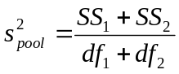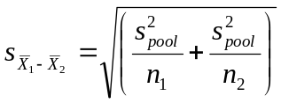

Casual Group  (X₂) |  | X – | (X –)²
86
99
95
94
72
110

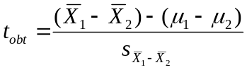

Step 4. Make a decision. Determine whether the value of the test statistic is in the critical region. Draw a picture. Label t_{crit} and t_{obt}.
Is t_{obt} in the critical region? ___________
Should you reject or retain the H₀? ___________

Step 5. Report the statistical results.

Step 6. Write a conclusion.

Step 7. Compute the estimated d.
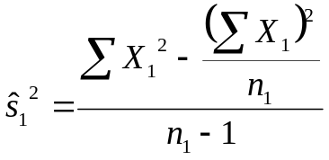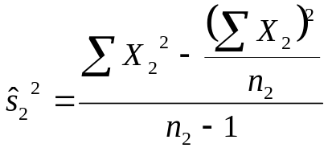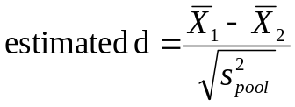

Step 8. Compute r² and write a conclusion.
